RAJALAKSHMI ENGINEERING COLLEGE

**RAJALAKSHMI NAGAR, THANDALAM – 602 105**



|  |
| --- |
| **CS23A34**  **USER INTERFACE AND DESIGN LAB** |
| **Laboratory Observation NoteBook** |

**Name :** VIKNESHKUMAR M.N

**Year/Branch/Section :** II/CSE/D **Register No. :**230701382

**Semester :** IV

**Academic Year:** 2024-25

**Ex. No. : 4b**

**Register No. : 230701382 Name: Vikneshkumar M.N**

# Conduct task analysis for an app (e.g., online shopping) and document user flows. Create corresponding wireframes using dia

**AIM:**

The aim is to perform task analysis for an app, such as online shopping, document user flows, and create corresponding wireframes using Dia.

# PROCEDURE:

Tool link: <http://dia-installer.de/>

1. Install Dia:
   * Download Dia from the official website [(http://dia-installer.de/)](http://dia-installer.de/))
   * Install Dia on your computer
   * Open Dia:
   * Launch the Dia application.
2. Create New Diagram:
   * Go to File -> New Diagram.
   * Select Flowchart as the diagram type.
3. Add Shapes:
   * Use the shape tools (rectangles, ellipses, etc.) to create wireframes for each screen.

* For example:
* Home Page: Rectangle
* Product Categories: Rectangle
* Product Listings: Rectangle
* Product Details: Rectangle
* Cart: Rectangle
* Checkout: Rectangle
* Order Confirmation: Rectangle
* Order History: Rectangle

1. Connect Shapes:
   * Use the line tool to connect shapes, representing the user flows.

* For example:
* Home Page -> Product Categories
* Product Categories -> Product Listings
* Product Listings -> Product Details
* Product Details -> Cart
* Cart -> Checkout
* Checkout -> Order Confirmation
* Order Confirmation -> Order History

1. Label Shapes:
   * Double-click on each shape to add labels.

* For example:
* Label the rectangle as "Home Page", "Categories", "Product Listings", "Product Details", "Cart", "Checkout", "Order Confirmation", "Order History".

1. Save the Diagram:
   * Go to File -> Save As.
   * Save the diagram with a meaningful name, such as "Online Shopping App User Flows".

# OUTPUT:

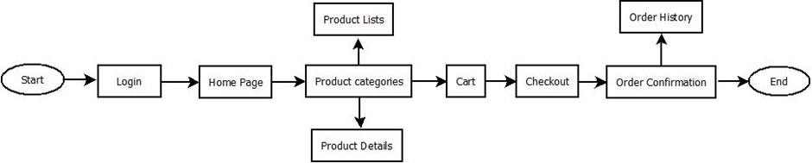

**RESULT:**

Hence, to perform task analysis for an app, such as online shopping, document user flows, and create corresponding wireframes using Dia has been successfully executed.